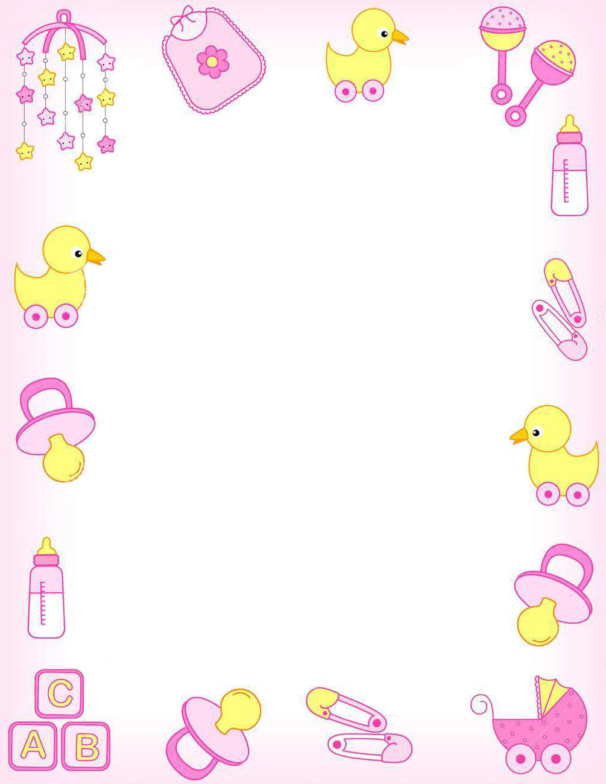

Scrapbooking Supply Drive

Supporting Maria Fareri Children’s Hospital
at Westchester Medical Center

The scrapbooking program at the hospital is in need of:

- 12inx12in Scrapbooks (Pink/Blue or Baby/Family Themed)
- 12inx12in Scrapbooking Paper (Preferably Baby Themed)

- Baby Themed Stickers/Embellishments
- Family Themed Stickers/Embellishments
- Holiday Themed Stickers/Embellishments
- Sticker Letters

- Glue Dots
- Two-Sided Tape
- Glue Pens

- Extra 36-Print Cartridge for Smartphone Photo Cube & Wi-Fi Photo Printer (http://www.sharperimage.com,
Item #201722)
- Silhouette CAMEO 12” Cutting Mat (www.michaels.com)

“Brighter Days for Hospital Stays”
Girl Scout Gold Award Project By: Lauren Steinitz

In 2015, as her Girl Scout Gold Award “Take Action” Project, Lauren Steinitz revamped the scrapbooking program for parents of children in the Regional Neonatal Intensive Care Unit (RNICU) at Maria Fareri Children’s Hospital at Westchester Medical Center (MFCH). Considering that this is an ongoing program, the Child Life and Arts Therapy Department at Maria Fareri Children’s Hospital at Westchester Medical Center is always in need of the listed supplies above. Any donation that you could make to the hospital would be greatly appreciated!

